Scot.E3: Employment, Energy, Environment
An Energy Policy Consultation paper
In 2014 the Scottish government initiated an energy policy review. The purpose of this review was to examine the present state of Scotland’s energy economy and consider future options in the light of both a looming climate crisis and also the optimum strategy for replacing ageing fossil fuel and nuclear generating capacity with a range of renewable technologies.

In 2017 in order to ensure employment and fuel poverty issues were taken into account in this review, an infant SCOT.E3 decided to submit its own paper in an attempt to ensure that a full spectrum of related energy and environmental issues were incorporated into a memorandum of evidence.

Yet five years on and despite an almost universal acknowledgement of an accelerating climate crisis, little has been done- in practical terms- to address an impending environmental disaster and its related social and economic consequences. Also, within the intervening period, we have seen the commercial collapse of the BiFab renewable power technology company at Burntisland as well as the continued interest of the petro-chemical company Ineos in activating its shale gas fracking options to the point that it will feel confident to test the validity of the current Scottish governments ‘anti-fracking’ moratorium.

So it is against this present uncertainty that SCOT.E3 is now initiating another energy policy review to which it invites all interested parties to participate. The aim of this exercise is to re-examine the range of issues needed to be addressed; a renewable energy economy and the availability of appropriate technologies, the issue of fuel poverty and affordability of energy, energy efficiency, energy related employment and just transition possibilities regarding current energy and defence related employment, improvement of housing stock and carbon neutral public transport systems- to name but a few.

And as can be seen from the attached paper, SCOT.E3 have made a start in outlining the historical record of electricity generation and supply in Scotland in order to reinforce the case for a major stage in meeting Scotland’s forthcoming energy and environmental needs- a long promised Scottish state owned energy company.

We are therefore inviting you to participate in this exercise by adding your comments and/or contributions under the section headings so far left blank. This is to ensure that any report fully takes into account the range of opinions that truly reflect the technical and scientific know-how- as well as the concerns of environmental, community and trade union campaigns and interests engaged in these vital and urgent issues.

In order to ensure that this exercise is properly democratic, it is our intention to hold a consultative meeting for all consultees in the near future, as well as a major workshop type conference in the autumn.

We hope that you find the introductory notes both useful and of interest and we look forward to hearing from you in the near future. For any further information please contact:
SCOT.E3 at www.scote3.wordpress.com, email triple.e.scot@gmail.com


A SHOCK TO THE SYSTEM
THE CASE FOR
A PUBLICALLY OWNED AND DEMOCRATICALLY ACCOUNTABLE SCOTTISH ENERGY COMPANY (ELECTRICITY)

An invitation to contribute to a SCOT.E3 policy consultation paper and memorandum.
Spring 2019

1.INTRODUCTION
The utility privatisations of the 1980’s were founded on market dogma rather than any sort of rational system management dedicated to the principle of affordable public service. In order to ensure the maximum extraction of profit with the least commercial risk, the cost of liabilities were not factored into what had to be a fractured and ‘competitive’ generating, supply and distribution chain in which no liability for security of supply would be attributed.

In order to ensure the attractiveness of such ventures to private investors, the natural tendency to monopoly- and hence supply failure attribution- was overcome by separating (in the case of electricity) the generation, distribution and supply operations. And then, over a number of phased regulatory changes, the regional franchise and specific designated duties were removed. Ostensibly to ensure the free operation of a market and a spirit of competition, a ‘light hand’ of regulation was the watch-word from the start.

However, the 1989 Electricity Act which was hailed as ‘the sale of the century’ proved to be an abject failure that only presented the Treasury with bills through corporate share purchases which proved to be totally risk averse at the prospect of inherited inestimable nuclear liabilities- let alone future capital cost risk entailed in future nuclear build.

VERTICAL DISINTEGRATION

Historically (and globally) electricity utilities had evolved on the basis of both statutory regulation and vertical integration- the latter meaning the integration of power generation, supply and distribution by a single utility via a common carrier ‘from power station to plug socket’. In such a system common ‘wires’, carriage charges and diurnal tariffs would apply- all subject to system transparency overseen by a regulator with punitive powers.

In the UK, such a power supply system had evolved via nationalisation in 1929 under the Conservative government of Stanley Baldwin in order to overcome the chaos of an unregulated and speculatively evolving system with no common electricity voltages, let alone entailed security of supply conditions. The system that eventually evolved in the UK was one of vertical integration of standardised power generation connected via a National Grid to regional electricity boards.

In Scotland, a simpler system of a Scottish Hydro Board and a South of Scotland Electricity Board shared responsibility for a shared grid connected to sub-regional distribution and supply systems. In both cases, regulation was via grid regulators imposing- and expecting- a responsibility for security of supply.

By strategic standards for a state-owned system, an over-capacity was deliberately built into both the generating and supply elements- to take into anticipated demand growth as well as factoring-in life-time plant redundancy and replacement schedules. It was also part of a belt-and-braces planning culture that at any one time, there would be a generous plant margin that could take into account extreme ‘average cold (weather) spells’ as well as sudden and unscheduled outages of generating sets or grid sectors.

Consequently, at the time of privatisation, the combined generating inventory of the UK’s CEGB/SHB/SSEB was at a 23% ‘over-capacity, with Scotland as a ‘region’ with a population of only 5 million, with a significant hydro component, standing at 43% over-capacity.

And although operating to a large extent as separate entities, the England/Wales and Scottish electricity systems did share a culture of strict vertical integration and substantial operating plant margins. Also, a shared tendency towards bigger and more fuel efficient fossil fuel combustion designs were evolutionary features of power generation on both sides of the border.

Operationally, an economic system of plant rotation was chosen to ensure that the most efficient generating sets on a basis of availability- a ‘merit order’- meant that maintenance- or unscheduled ‘outages’ could be planned in order to ensure that the biggest, newest and most fuel efficient sets would be available for seasonal periods of high demand. This ensured both maximum plant utilisation and lowest peak demand generating cost.

However, when subjected to pre-privatisation assessment, such a combination of a merit-ordered vertically integrated system was seen to be uncompetitive and contrary to market principles- and as such was regarded as an obstacle to privatisation- regardless of the evident economic benefits. As such, the system and the managerial culture that it engendered had to be dismantled as a prerequisite to ‘the sale of the century’. And in the process, one of the main objectives of a publically owned and operated power utility- security of affordable supply- was ditched as a hindrance to the remuneration of future shareholders.

2.SCOTLAND

Since its inception the demand for electrical power has been driven by a coincidence of local demand and local availability of fuel- or reserved energy in the case of Scotland; geological and topographical factors- the coal measures of the Central Belt (or Midland Valley)- and the water volumes of the hills, lochs and valleys of the Highlands.

Initially, as the demand for electricity lagged behind that of coal as the fuel for domestic needs as well as town gas’ for street lighting- as well as for the industrial requirements of coking coal for iron and steel production, the use of coal in power generation did not arise until the immediate pre-1914-18 war, by which time a significant amount of electricity was already being provided by hydro-electric turbines.

And it was this ‘energy mix’ of coal and hydro power that prevailed in Scotland until the advent of nuclear power in the mid-1960’s onwards- although with seasonal rainfall fluctuations, coal quickly gained its stronghold as the baseload (round-the-clock, all year round) generating source of choice.

Initially, the largest post-1929 Electricity Act Scottish power input was from hydro- the first public- system stations of which had been installed as early as 1878. And even today with 72 hydro sites operating across Scotland there is one single turbine unit dating from 1902 still in operation. It is this hydro-electric turbine potential combined with a relatively modest industrial demand for electricity in Scotland prior to around the mid-1930’s that resulted in a relatively modest thermal power capacity, despite the considerable coal reserves across the Central Belt, Fife and Ayrshire.

However, by post-1945, and with a considerable state reinvestment in industrial capacity ear-marked for Scotland, new large-scale coal-fired power stations were planned- only to be cut back with the advent of a too-cheap-to-meter nuclear illusion to distort the energy mix. This was despite the fact that Scotland had nothing like the regional capacity-need that the combined Magnox and later AGR programmes resulted in. Indeed, it is now well known that the demand justifying the construction of the Hunterston B and Torness AGR’s was a falsified estimate of the power requirements that the British Aluminium smelters at Invergordon and Fort William would make on the baseload of the system.
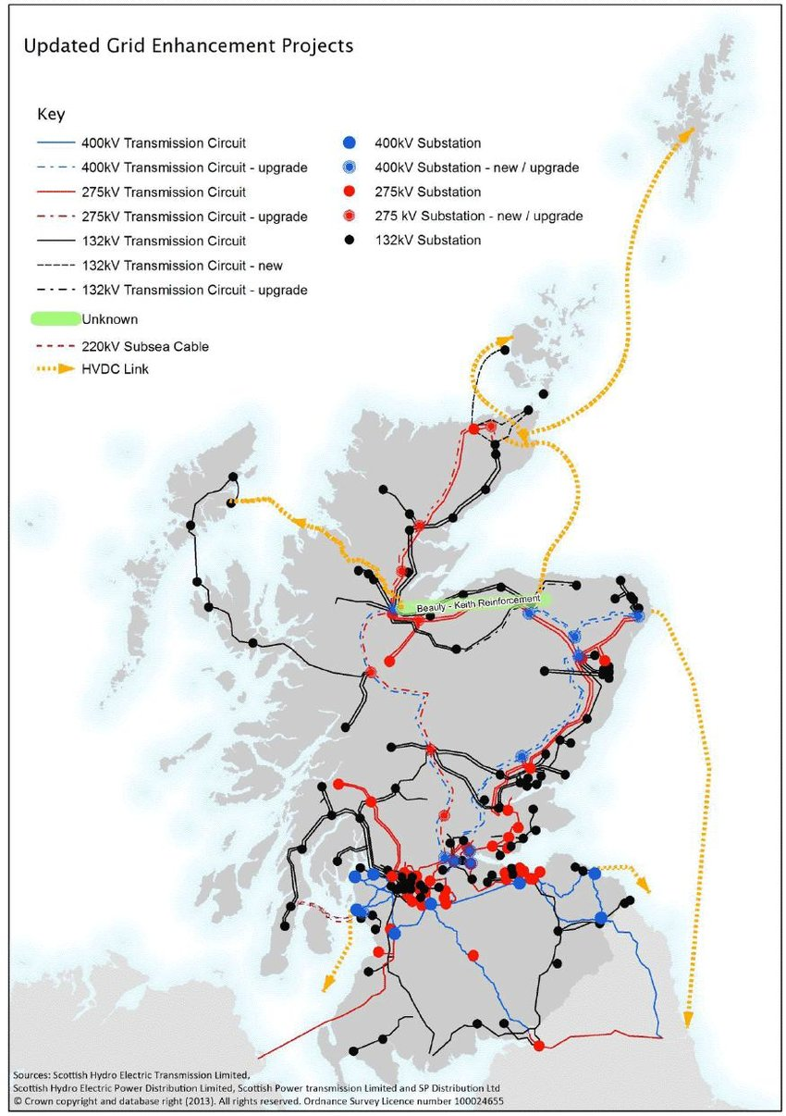
But the ‘energy policy’ option pursued by successive UK governments of a ‘balanced energy policy’- effectively one of not too many eggs in one basket, also meant the commissioning of new large-scale coal-fired power plant. This resulted in the late 1960’s the planning of the 1200 MWe station at Cockenzie to be followed by what was to be (for 8 years) the largest coal-fired power station in Europe weighing-in at 2200 MWe at Longannet.

And just to make sure that the ‘energy-mix’ might ensure security in the event of a future miners strike, a massive oil-fired 1990 MWe station at Inverkip on the Ayrshire coast was built just in time for the Yom Kippur war and the quadrupling of oil prices. It was never used.

So on the eve of the privatisation of the UK Electricity Supply Industry (ESI), thermal generating capacity (all fuels) was as set out in Table 1.
Fig 1. Scottish grid systems (planned) prior to privatisation

TABLE 1 Scotland Gross Registered Capacity (GRC) THERMAL 1986

Nuclear

Station Type MWe Opened Closed
Chapelcross Magnox 200 1959 1989
Dounreay FBR 250 Never commissioned 1994
Hunterston A Magnox 360 1964 1990
Hunterston B AGR 1288 1980 ----
Torness AGR 1364 1986 ----

TOTAL Nuclear 3462

Coal
Cockenzie 1200 2013
Kincardine 760 1997
Longannet 2400 2016
Methil 57 2000
Barony 60 1989

TOTAL coal 447Oil/gas
Inverkip (oil) 1990 1998
Peterhead (gas) 1550 ----
Grangemouth CHP (gas) 130 ----
Misc: small diesel etc. 123

TOTAL Oil/gas/misc 3793

TOTAL GRC All Thermal 1986 11732 MWe

NON-THERMAL POWER RESOURCES 1986

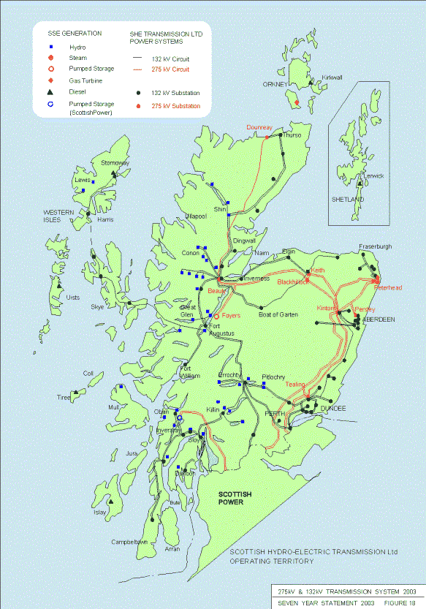
As stated above, Scotland has since the end of the 19th century enjoyed a growing power contribution from hydro-electricity. Subsequently, this only seasonally power source, had, by 1986, grown to an installed capacity of 1500 MWe- in addition to which two pump storage stations (Cruschan- 440 MWe and Foyers/Loch Mhor- 300 MWe) added a further 740 MWe to the total hydroelectric of capacity.

Scotland’s hydro capacity, installed as it was, largely in the earlier part of the 20th century, was a particularly attractive asset for the private sector to take over. Capital investment and interest had long been written-off; the plant itself is both simple and elegant in design with little incorporated costs regarding repair, maintenance and refurbishment. Furthermore, the fuel- rainfall- is free- and although limiting hydro to the less rainy seasons of autumn and winter/early spring, this supply availability also coincides with the periods of highest power demand. The other operational feature of hydro was- and still is- the flexibility that a number of relatively small generating units, available at different times, but all able to come on line at short notice- should sufficient headwater capacity allow.

Fig 2. Map of Scottish hydro distribution system

Also, the small capacity of such units made for unobtrusive demands- both visually and in terms of maintenance requirements on a wilderness amenity landscape, and with little interference with wildlife routes.

It should also be noted that at the time of privatisation no alternative non-thermal capacity had been planned or commissioned on the UK ESI system.

Therefore, all generating sources- conventional and nuclear thermal- plus hydro and hydro-storage at the time of privatisation in 1989 for Scotland totalled 13,972 MWe.

3.ELECTRICITY PRIVATISATION

Of all of the Thatcher privatisations, electricity was by far the most ambitious, technically challenging and intellectually demanding. And like rail, subsequent to it, it was also a failure. A vertically integrated and relatively technically uniform and proven system of generation, supply and distribution needed, in the name of competition, to be broken up and its operation subjected to a ‘light hand’ of regulation with the market the ultimate arbiter.

And while the UK ESI could be likened to a Behemoth it was by no means a monolith. Operational cultures either side of the England/Scots border were in some ways similar, but topography and population densities and distribution had exerted major influences on both energy mixes and decisions regarding optimal plant size. And although supply systems regarding super-grid and distribution design conditions were identical, little in the way of high capacity interconnections initially linked the Scots and English systems.

However, both the CEGB and SSEB/SHB as established with a revamped National Grid immediate post-war, shared the same imperative of security of supply with the capacity margins required to meet such exacting demands. But by the late 1950’s another national energy imperative under the banner of ‘atoms for peace’ was to see the UK’s essentially military nuclear industry take on an apparently ‘civil’ face with a nationally planned nuclear reactor programme, ostensibly dedicated to ‘clean’ and ‘too cheap to meter’ electricity.

However, it was the nuclear generating component in the UK power mix that almost rendered the ESI privatisation a total failure- and one that resulted in the largest component in Scotland’s power mix totally unconducive to the risk-averse brave new world of City spivs and their insurance under-writers. It would therefore be useful to discuss how the nuclear baseload element of Scotland’s ESI determined the shape of its eventual privatisation and how it has distorted both the economics and the characteristics of the generating capacity we see today.

Nuclear: MAGNOX

Following the first electricity producing prototype reactor at Windscale- now Sellafield- the decision was taken in 1955 to scale-up a gas-cooled graphite moderated reactor design for economic commercial power production. As this type of reactor was to be protectively clad in a magnesium alloy metallic shielding, the reactor type was to be called the Magnox.

Scotland was to have the dubious honour of hosting the first stage of the Magnox programme with a twin reactor station at Chapelcross in Dumfries and Galloway. This station comprised two 160 MWe reactors and began commissioned operation in 1959. This was followed five years later with another (slightly larger) twin 180 MWe reactor station at Hunterston in Ayrshire, which came on stream in 1965. In all, eight Magnox station were built- with the last, Wylfa in Angelsey North Wales shutting down in 2001.

An almost unique feature of the Magnox design was its conversion in the fission process of a proportion of the enriched Uranium fuel into Plutonium- the highly fissile material used in hydrogen bomb warheads- key to the US and (to a much lesser degree) the UK nuclear deterrent missiles. Indeed, so effective were the Magnox stations in ‘breeding’ Plutonium, that it was felt necessary to divert a significant amount of this surplus by-product into a more ‘advanced’ and powerful reactor type- the Plutonium Fast Breeder Reactor (FBR).

Nuclear: FBR (and ABR)

Due to the very high risk of radioactivity contamination in the event of a Plutonium fuel explosion, Scotland, and its most remote mainland sub-region of Caithness was the chosen location for the UK’s Fast (and Advanced) Breeder Reactor programme. About which little remains to be said other that the ABR station at Dounreay was never operationally connected to the Grid, and that the 250 MWe FBR- to be finally abandoned in 1994- had the dubious distinction of having consumed more electricity than it ever produced in its sorry and never fully commissioned existence.

Nuclear: Advanced Gas Reactor (AGR)

For the advocates of nuclear power in the UK Department of Energy, it was clear by the early 1970’s that in terms of reliability, output, capital cost and cost of output per kw/hr, the Magnox programme had been a failure. However, the political crises precipitated by two successive and victorious miners strikes proved to be a strong impetus to diversify away from a dependency on coal. And although there was a clear political consensus regarding a replacement and major nuclear programme, a row over the choice of reactor type was to erupt within the incoming Labour government of 1974 over a reactor type- either the US Pressurised Water Reactor (PWR) or the UK designed Advanced Gas (cooled) Reactor (AGR). Ultimately the new Secretary for State for Energy, Tony Benn, urged for the AGR in order to avoid an over-dependency on the US for strategic matters of energy security.

Despite strong protests against the AGR from within the UK nuclear industry on the grounds that it represented a wholly untested departure in terms of reactor design, the choice, ultimately was for the AGR, two twin stations of which were constructed in Scotland. And in retrospect and in taking into account the performance and costs of the AGR programme, such opposition could be said to have been well founded.

- FINISH NUCLEAR AND EXPLAIN SCOTTISH OVER-DEPENDENCY RE BASELOAD
- ALSO REFER TO PETERHEAD AS CONSTRAINED-OFF REMAINING FOSSIL BASELOAD
- EfW CAPACITY (INCOMING) AS NON-RENEWABLE BASELOAD
- RENEWABLES SINCE PRIVATISATION: ONSHORE/OFFSHORE WIND- INCLUDE MAPS
- TIDAL POWER POTENTIAL- INCLUDE MAP
- WAVE POWER POTENTIAL- INCLUDE MAP

- WE INVITE COMMENTS/SUGGESTIONS RE:

- LEGISLATIVE AND REGULATORY ISSUES

- GREEN INVESTMENT BANK

- SOCIAL POLICIES RE HOUSING, FUEL POVERY, PREFERRENTIAL TARIFFS, SUBSIDIES ETC

- SOVEREIGN WEALTH FUND RAISED BY NORTH SEA LEVY ETC

- SOCIAL JUSTICE/SOCIAL ENGAGEMENT ISSUES (INEQUALITY, EMPLOYMENT, UNION RIGHTS, DEMOCRATIC CONTROL, ETC)

------------TO BE CONTINUED-----------

Contribution, suggestions, expert opinion required on the following:

PUBLIC POWER UTILITY: OPTIMUM MODEL (upper case)

Prerequisites:
- Green Investment bank (public with Treasury rates of return/discount rates)
- Consultation process
- Act of parliament
- Acquisition by Compulsory Purchase: nationalisation of assets
- Establishment of power utility company with following structure:

Generation>>Supply>>Distribution>>Democratic management>>Metering & billing>>Setting social tariffs>>Energy efficiency promotion>>Investment

PUBLIC/PRIVATE PARTNERSHIP UTILITY: (CENTRAL CASE)

- Investment bank (public with Treasury rates of return/discount rates?- or money markets?)
- Consultation process
- Act of parliament
- Partnership and management of assets
- Mixed venture power utility with following structure:

Generation>>Supply>>Sale of power to distribution municipal co-ops>>Setting local tariffs>>Metering and billing>>Energy efficiency promotion>>local management (community)

PUBLIC/PRIVATE POWER UTILITY: MINIMAL MODEL (lower case)

- Investment bank (public)
- Private ownership within public charter terms
- Consultation re planning and cost issues
- Act of parliament to obtain power purchase license and some supply infrastructure
- Establishment of power supply company with following supply responsibilities:

National wholesale power purchase rights>>Retail Distribution and power sales>>metering & billing>>Setting social tariffs>>Energy efficiency promotion

